Instructions for I3 P&H Tig Machine Setup

Safety:
Eye protection. You must wear welding helmet. Gas welding goggles are not acceptable. You shold be wearing gloves on both hands. You should be wearing long sleeve shirt, long pants, leather shoes.

Turn on the Argon Gas bottle at the wall rack. Remember that the seal system for inert gas only completely seals the stem at full closed and full open. Turn the knob in the desired direction until it stops. When the TIG machine is turned on, you can adjust the argon flow (watch the red ball in the vertical glass tube).

Check the power switch on the junction box on the wall. Is it turned on?

Quirks of the I3 P&H TIG machine.
1) Sometimes the foot pedal sticks just enough to turn on the solenoid. This is very bad, particularly if you are using an old style welders shield. Its too easy to flash your eyes in error. Best action, is to ensure foot pedal is at top of stroke before you turn on the machine.

2) Argon use. The machine flows argon gas whenever the machine is turned on. Argon gas is expensive. This means turn off the machine when you have finished your weld, and don’t turn it on again until just before you are ready to run your next bead.

Machine settings: What are you welding?

Steel? If you are using steel, set the Polarity Selector Switch (large three position switch on the right hand lower area) to the full clockwise position, Direct Current Straight Polarity (DC Electrode Negative)

You should be using the red tungstens (2% Thoriated) for DC TIG welding.

Aluminum? If you are using aluminum, set the Polarity Selector Switch to the full counterclockwise position, Alternating Current (AC).

You should be using the green tungstens (pure tungsten).for AC TIG welding.

Choose machine settings and tungsten based on the following chart:

Material Being Welded | Material Being Welded Thickness | Tungsten Type | Tungsten Electrode Diameter | Cup Opening (ID) | Filler Metal Diameter | Polarity | Amperage Range (Amps) | P&H Range Selector Switch | Argon Flow Rate | Welding Speed | Notes:
Steel | 1/16" | Red (2% Thoriated) | 1/16" | 1/4 to 3/8 | 1/16" | Straight Polarity (DCEN) | 50-80 | Medium  22 to 162 Amps | 11 cfh | 12 inches / minute
Steel | 3/32" | Red (2% Thoriated) | 1/16" | 1/4 to 3/8 | 1/16" | Straight Polarity (DCEN) | 80-110 | Medium  22 to 162 Amps | 11 cfh | 12 inches / minute
Steel | 1/8" | Red (2% Thoriated) | 1/16" | 1/4 to 3/8 | 3/32" | Straight Polarity (DCEN) | 85-120 | Medium  22 to 162 Amps | 11 cfh | 12 inches / minute
Steel | 3/16" | Red (2% Thoriated) | 3/32" | 1/4 to 3/8 | 1/8" | Straight Polarity (DCEN) | 125-200 | High  78 to 342 Amps | 13 cfh | 10 inches / minute
Steel | 1/4" | Red (2% Thoriated) | 1/8" | 1/2 | 3/16" | Straight Polarity (DCEN) | 225-300 | High  78 to 342 Amps | 13 cfh | 5 inches / minute | Oops. Too hot for air cooled torch. Requires water cooled torch.
Aluminum | 1/16" | Green (pure tungsten) | 1/16" | 1/4 to 3/8 | 1/16" | Alternating Current (A/C) | 65-75 | Low  10 to 72 Amps | 15 cfh | 12 inches / minute
Aluminum | 1/8" | Green (pure tungsten) | 3/32" | 3/8 to 7/16 | 3/32" or 1/8" | Alternating Current (A/C) | 115-135 | Medium  35 to 205 Amps | 17 cfh | 12 inches / minute
Aluminum | 3/16" | Green (pure tungsten) | 3/32" | 7/16 to 1/2 | 3/32" | Alternating Current (A/C) | 125-150 | Medium  35 to 205 Amps | 21 cfh | 11 inches / minute
Aluminum | 1/4" | Green (pure tungsten) | 3/32" | 1/2 to 3/4 | 3/32" | Alternating Current (A/C) | 190-220 | High  112 to 420 Amps | 25 cfh | 10 inches / minute (If using 1/8 filler rod, use 2 passes)
Aluminum | 3/8" | Green (pure tungsten) | 1/8" | 5/8 | 1/8" | Alternating Current (A/C) | 110-260 | High  112 to 420 Amps | 29 cfh | Requires 2 passes, 1st pass 3/32 filler@220-260 amps, cover 1/8" filler at 110-130 amps | Oops. Too hot for air cooled torch. Requires water cooled torch.
Aluminum | 1/2" | Green (pure tungsten) | 1/8 or 5/32" | 5/8 | 1/8" | Alternating Current (A/C) | 120-290 | High  112 to 420 Amps | 31 cfh | Requires 5 passes, 1st pass 3/32 filler@270-290 amps, remainig passes 1/8" filler… | Oops. Too hot for air cooled torch. Requires water cooled torch.

Other machine settings? Set the large Output Control knob to desired setting. The foot pedal will control the actually amperage output to the maximum set on the dial. If you need less heat, back off on the foot pedal. If you need more heat, press the foot pedal further down.  Flipper switches, set: Remote Control , Soft Start Operative / Inop (per users discretion), Inert Gas Arc Welding, High Frequency Starting Continuous (per users discretion).  There are two small black dials on the right hand side of the machine, These are for the high frequency start circuit. Normally both of these knobs are set such that the white indicator line on the knob is vertical. | 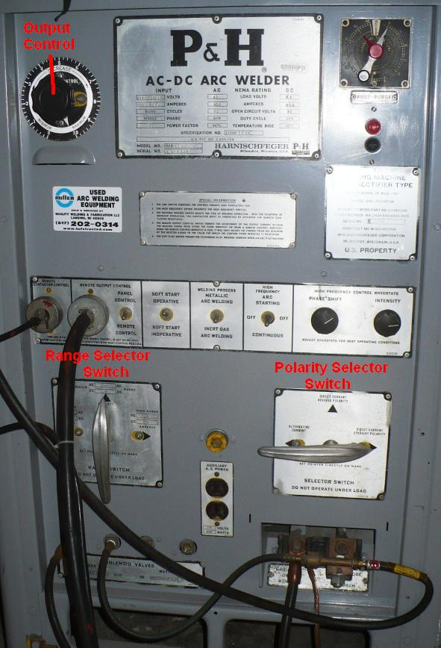
Getting ready to weld.
--Prepare all of your materials. Ensure you have clean metal, including stainless steel wire brush on all aluminum to remove the surface coat of aluminum oxide.

--As a general rule, set tungsten extension “stick out” distance equal to the diameter of the electrode. You may have to extend it further to reach some welds as required, but note this makes it harder to ensure inert gas coverage, etc.

--As a rule of thumb, while TIG welding, arc length (the distance between the end of the electrode and the work piece) is: One electrode diameter for A/C TIG welding, and usually considerably less for D/C TIG welding. Be careful to not allow the hot electrode to contact the weld puddle, or the filler rod. If you do touch, you will see a flash of light, and molten material will wick up and contaminate the tungsten electrode. When that happens, you should stop, regrind the electrode.

--If you want to get better, Practice, Practice, Practice!!

References:
Miller TIG Tips and Hints http://www.millerwelds.com/resources/tech_tips/TIG_tips/hints_tips.html

Miller TIG handbook (Free in downloadable PDF format) http://www.millerwelds.com/resources/TIGhandbook/

P&H Welder Manual http://www.tpub.com/content/welding/TM-5-3431-213-14/index.htm

